New Scrum Team Urban Turtle

1. **Get the name of the team.**

1. **Create a new Team under Dev.Scrum with Area path(Created automatically)**

* Access the below URL from Web Browser.

Q System https://etas-tfs-q.de.bosch.com/tfs/TFS01

P system https://etas-tfs.de.bosch.com/tfs/TFS01/

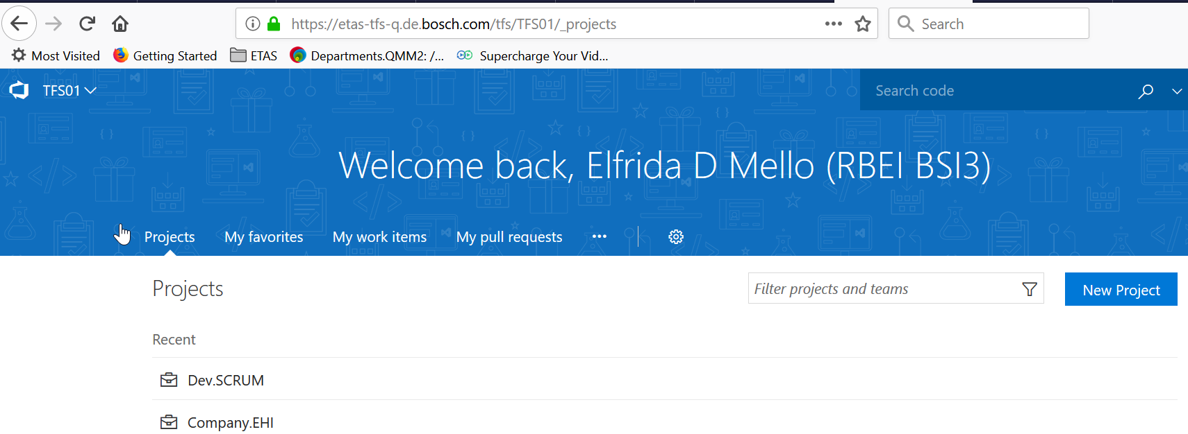

* Under TFS01 --> **DEV.SCRUM**

**Note: DEV.SCRUM is the only one Team project which uses Urban Turtle**

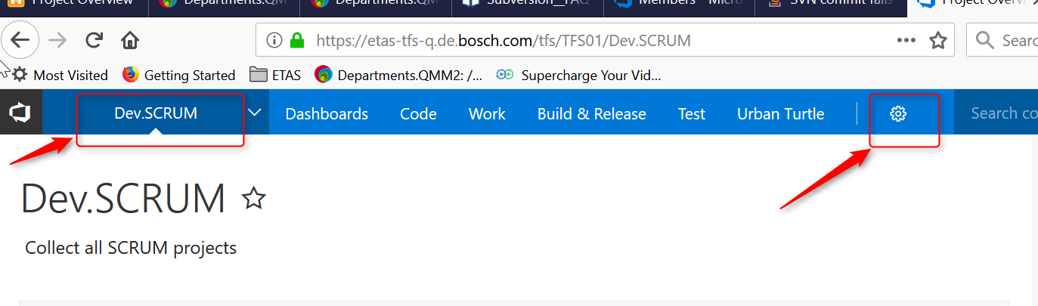

* Create a New Team Under DEV.SCRUM

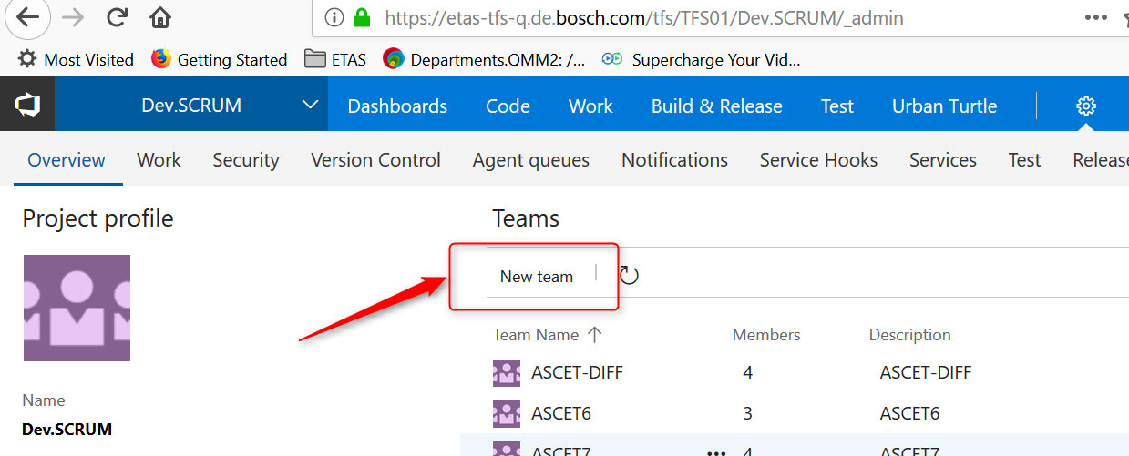

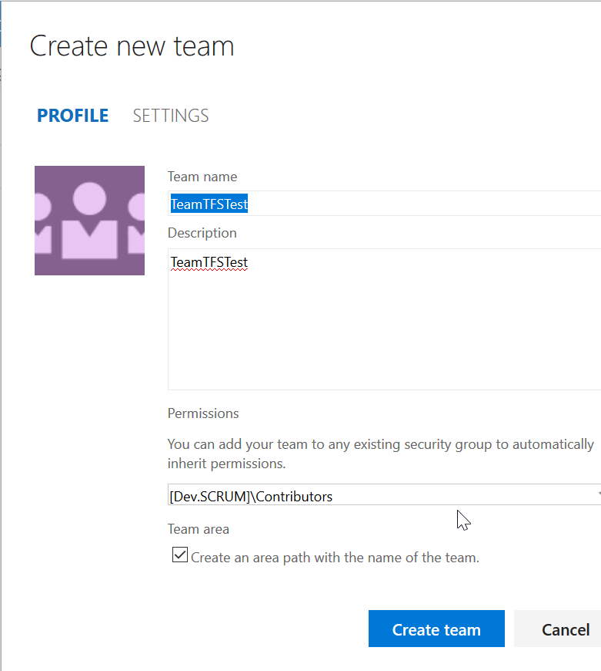

* By Clicking on the checkbox in above diagram it automatically creates an AREA to the particular team(Check the Tick box in Team area)

* Click on ADMIN gear button on topmost right corner.

Machine generated alternative text:
SMT - Service Managemen... X 
Company.EH1- ETAS FAQ 
Microsoft Team Foundatio... 
minister your server - 
Micro... 
x 
e 
OneDrive for Business 
rch 
G) siOvmc0437.de. 
bosch.com 
Most Visited Getting Stated 
ETAS J RBEIESS 
Visual Studio Team Foundation Sewer 2013 / Dev.SCRUM 
HOME 
CODE WORK 
BUILD 
URBAN TURTLE 
Ove rview 
Some features of Team Web Access are not visible to you. Show details 
o 
D Mello Elfrida (RBEIBSC2) 
Search work items 

1. **Add to admin group of the team under Overview Tab**

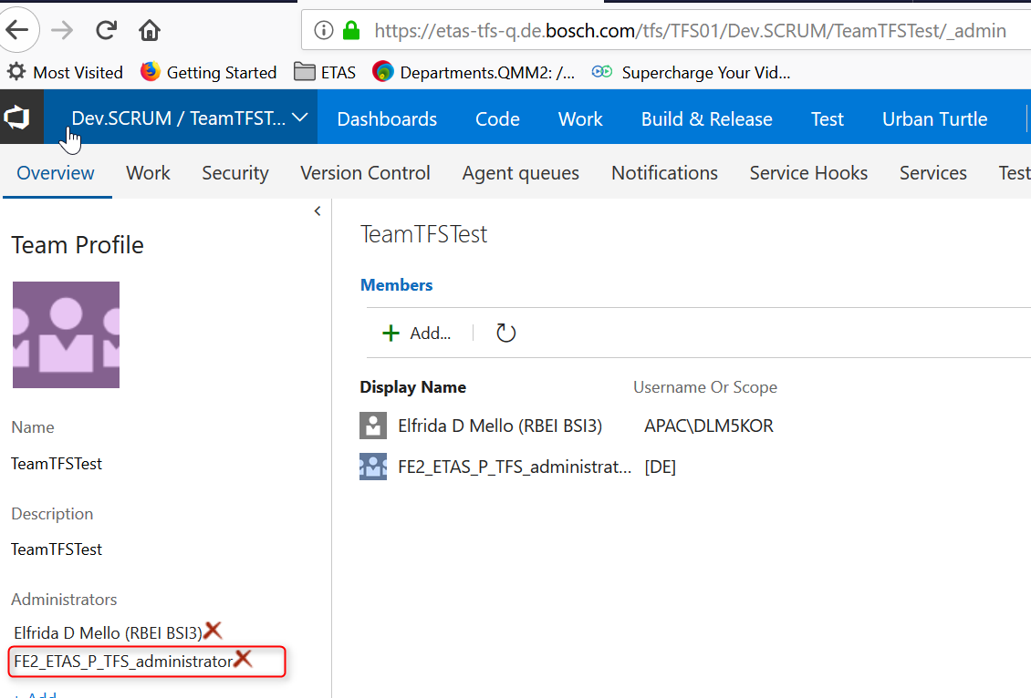

1. **Ask ITP to Create 3 AD Groups -**

FE2_ETAS_P_TFS_scc_scrum_<nameofteam>_administrator

FE2_ETAS_P_TFS_scc_scrum_<nameofteam>_employees

FE2_ETAS_P_TFS_scc_scrum_<nameofteam>_readers

1. **Create TFS groups.**

<nameofTeam> Administrator

<nameofTeam> Developers

<nameofTeam> Readers

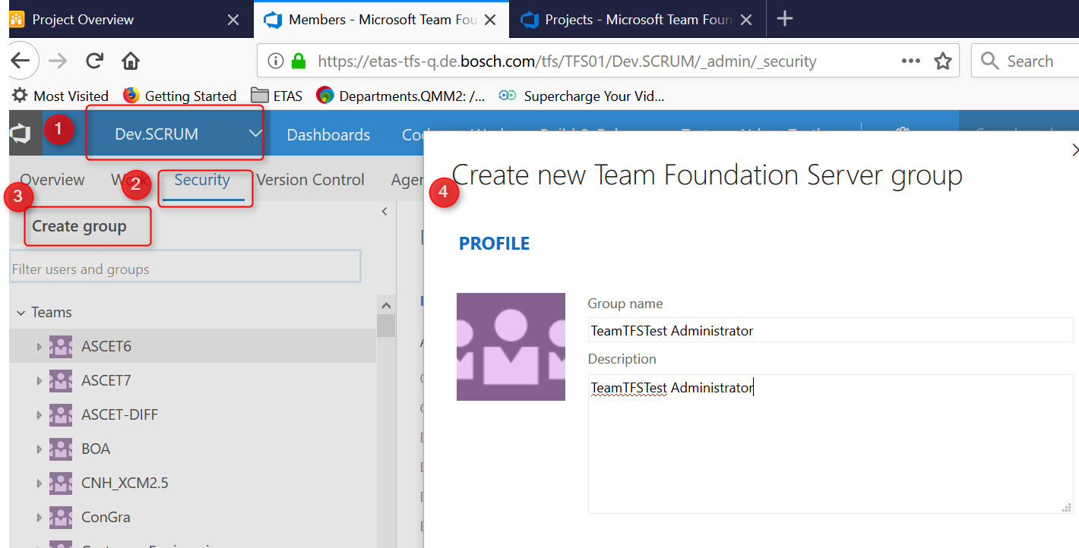

* Create the groups as below.

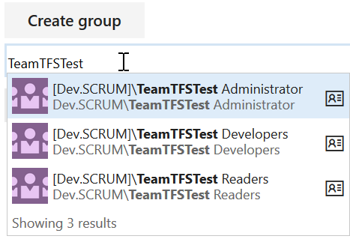

* Add all corresponding Windows AD group Under respective TFS group.

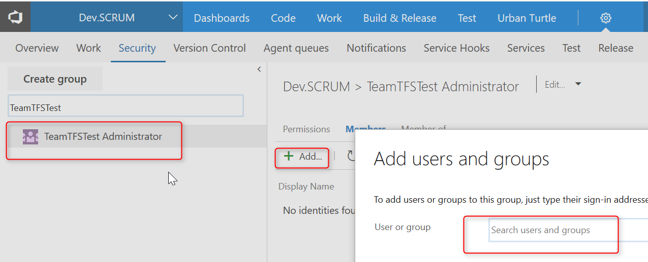

1. **Add All the 3 TFS Groups into Dev.SCrum\Contributors.**

Machine generated alternative text:
Control panel 
Overview 
Groups Users 
Create TFS group 
TFSOI Dev.SCRUM 
Security 
Alerts 
Version Control 
Urban Turtle 
Iterations 
Areas 
Dev SCRUM Contnbutors 
Permissions 
Add.. 
Display Name 
Members Member of 
Search 
Username Or Scope 
ConGra Admins 
ConGra Developers 
ConGra Readers 
Contributors 
(DevSCRUM) 
(DevSCRUM) 
(DevSCRUM) 
SCODE Tool Development Dev... 
SCODE Tool Development Rea... 
SCRUM Transition Team Admi... 

1. **Then click on TeamTFSTest on the below screen and right click "Set as default area on team".**

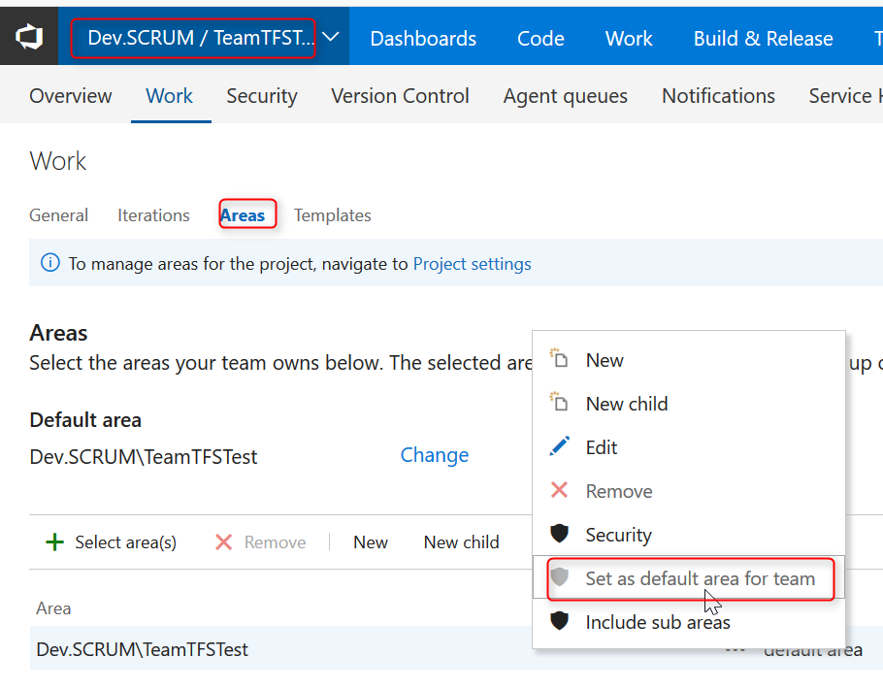

1. **Add permissions to the Area tab under TeamName**

* Assign Admin users access to all permission
* Assign Developer user access to edit work items and view work items
* Assign reader to have view work items

* Give Permission in Area tab for TeamTFSTest by Right clicking --> Security

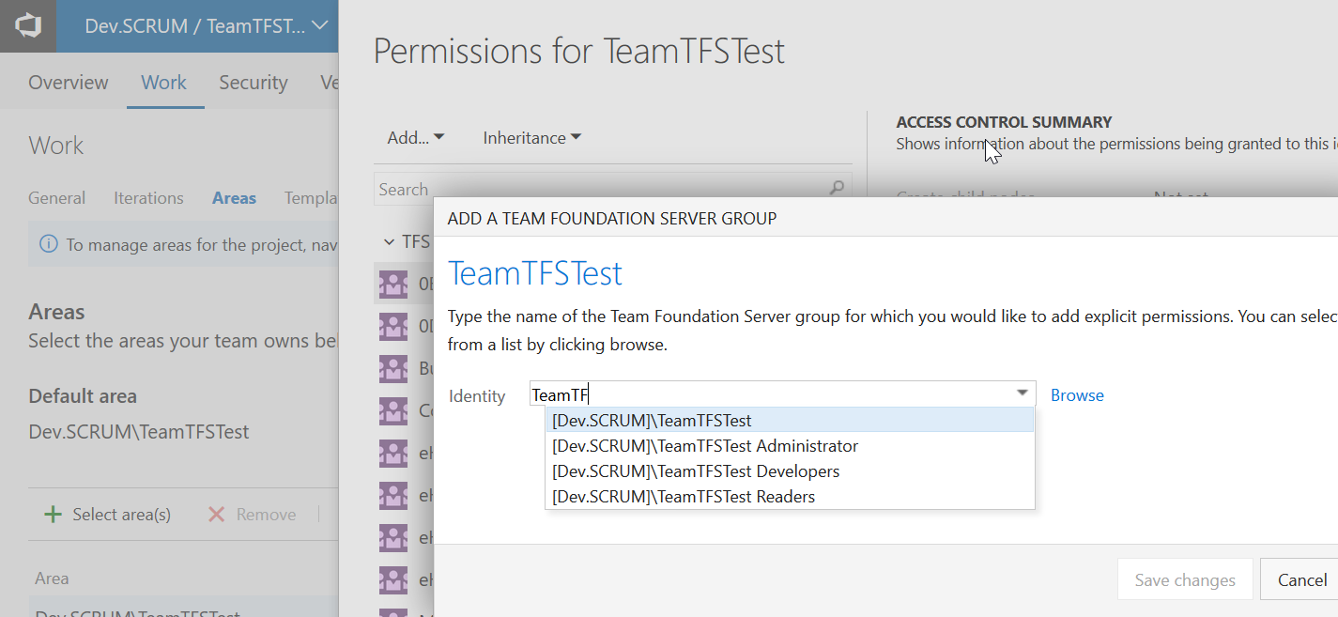

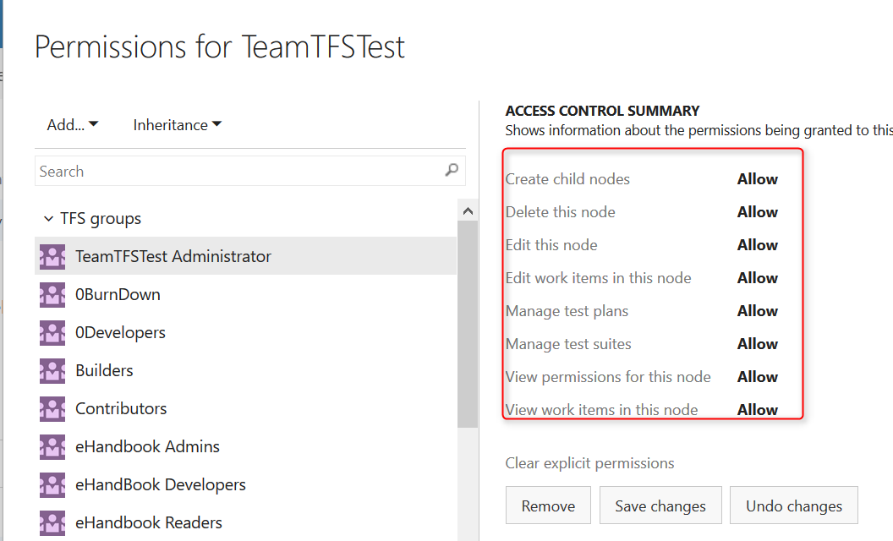

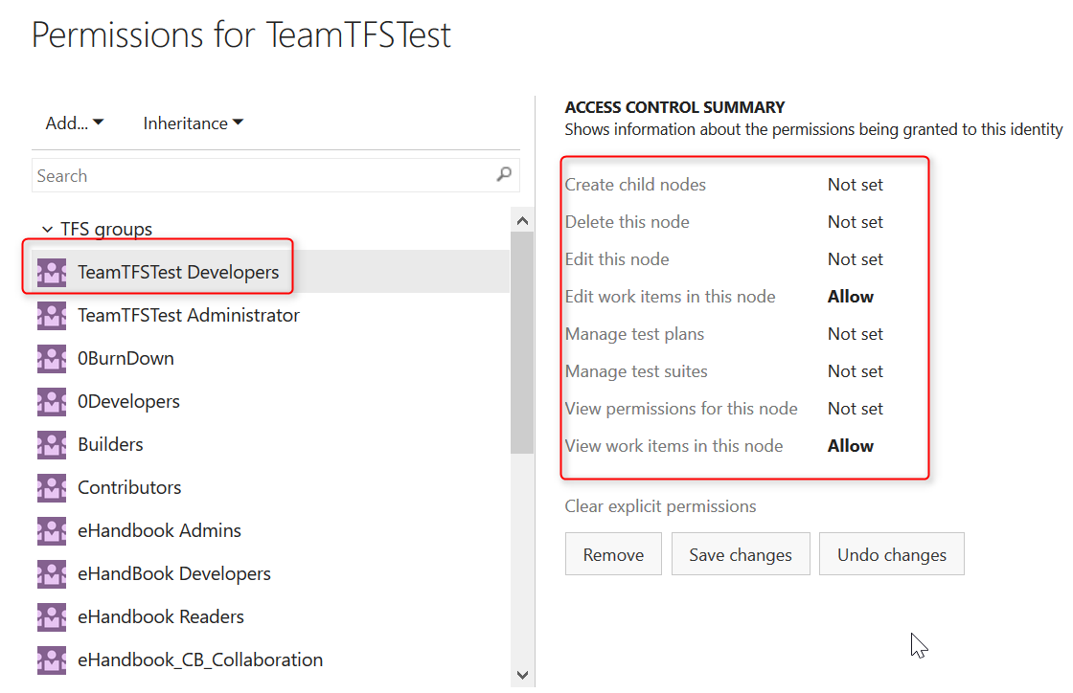

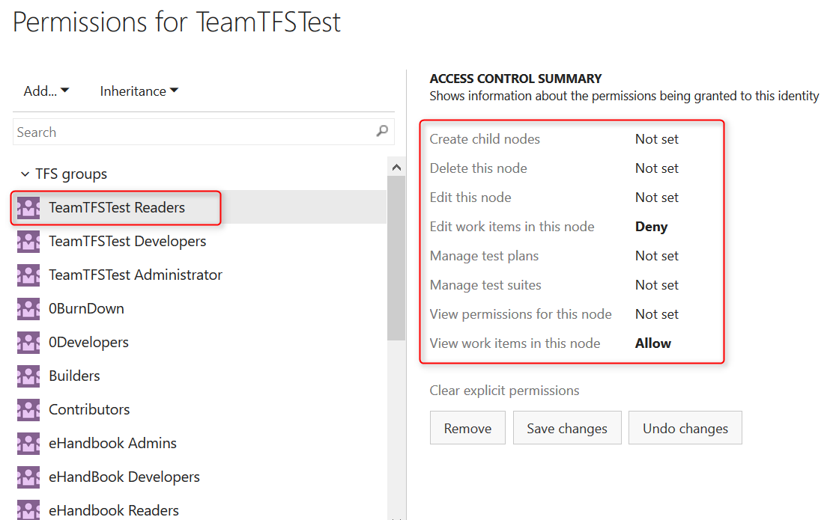

1. **Iteration with the name of team under Dev.Scrum by clicking on New Child and set the iteration to Set as Team Backlog's iteration((No need to give start date and end date)**

* Once iteration is created, Pleas add ONLY THE **Admin** TFS Group to the iteration and provide all the permissions

* ITERATION is nothing but a SPRINT, which increases its version accordingly.

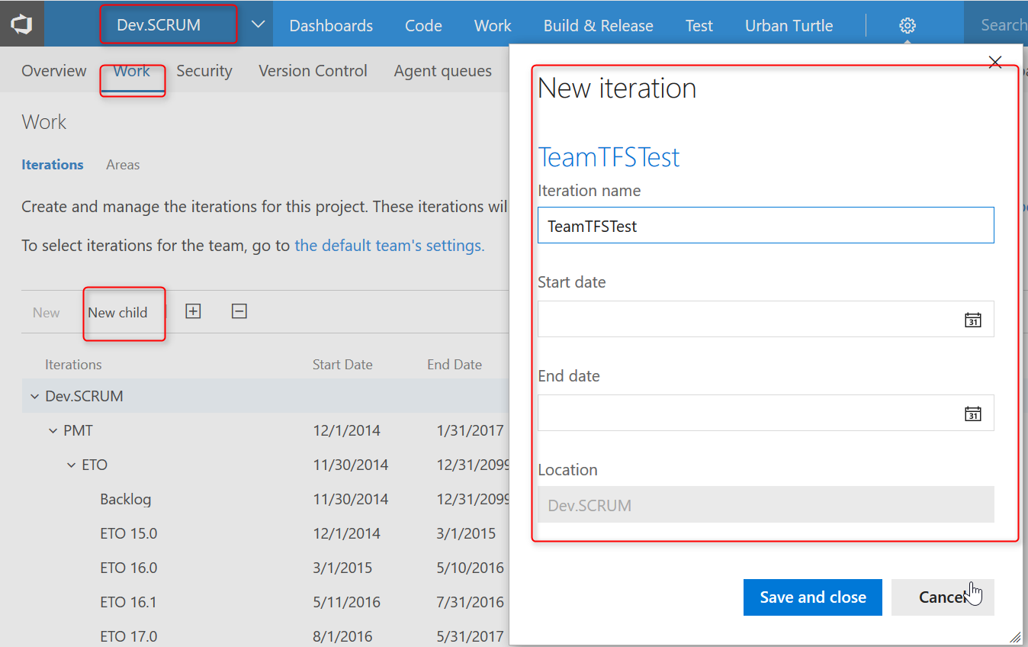

* Permissions: Right click on TeamElfrida Iteration

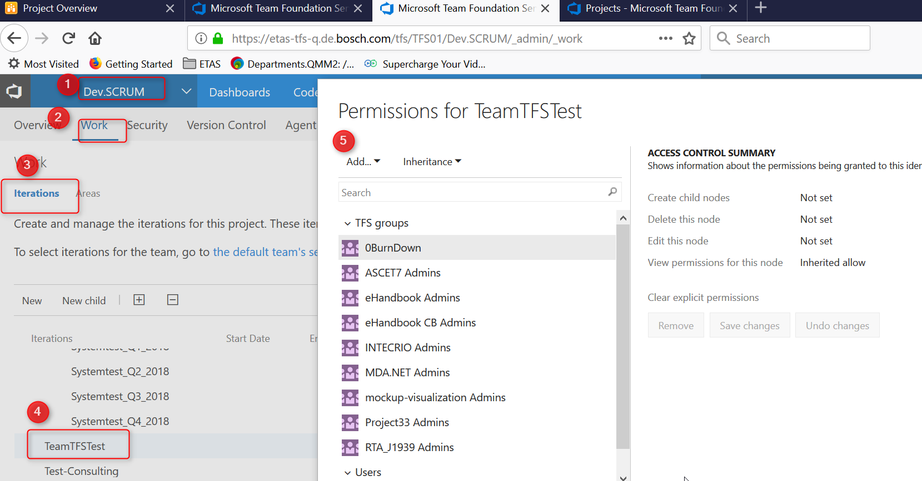

**For Iteration Permission only Administrator**

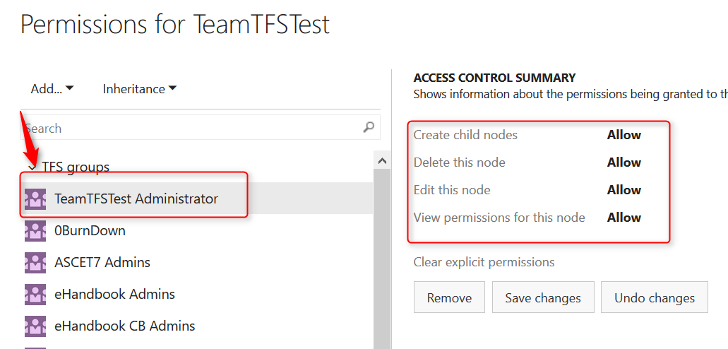

* **Create a folder with team name under Shared Queries-> Project Queries and assign access**
* Admin TFS Group all permissions
* Devlopers read and contribute
* Readers acesss to read only

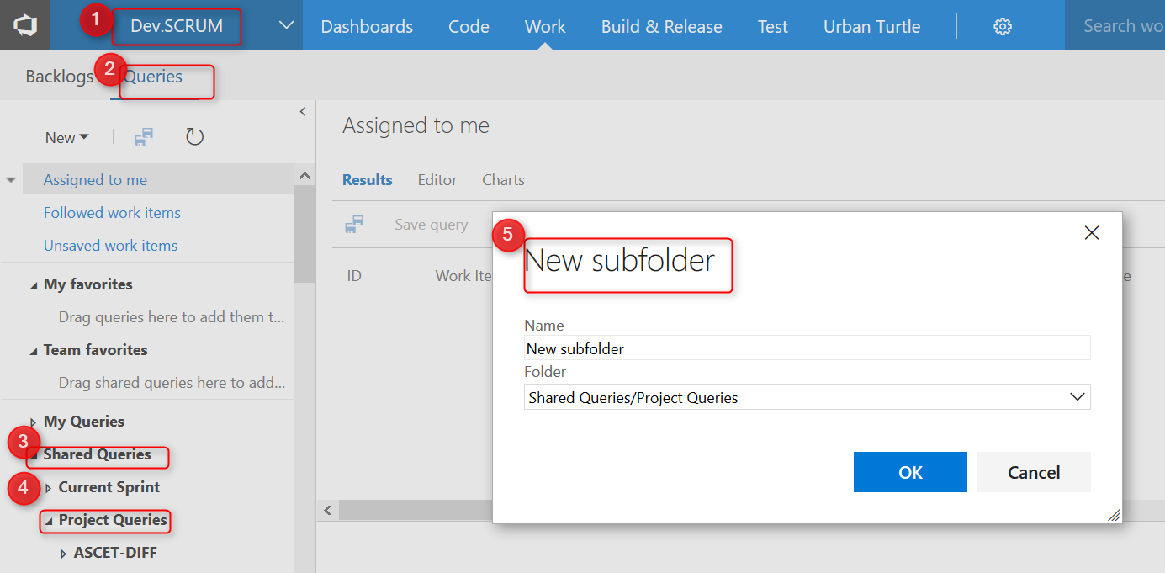

Right Click --> Security and then add all 3 permissions as listed in diagram below.

